

AMERICAN INTERNATIONAL UNIVERSITY BANGLADESH
COMPUTATIONAL STATISTICS AND PROBABILITY
SECTION: G
SUBMITTED TO: SAMIRA SALAM
SUBMITTED BY:

NAME | ID
REPHA TASNEYA | 23-50944-1
SHARID FARWAR SHIFAN | 23-50026-1
SUPTO KUNDU | 23-52281-2
EKRAM UL AZAD | 23-50160-1
SYED TAREK ALI | 22-494846-3

TITLE: Online Shopping Habits: A Look into Impulse Buying vs Planned Buying Among Different Types of People.
ABSTRACTION: This project explores online shopping habits, focusing on the differences between impulse and planned buying among various demographic groups. Primary data was collected to identify shopping frequency, influencing factors (like ads, discounts, or emotions), and the financial or emotional impacts of impulse buying. The study also looks at self-control strategies used to manage such behavior. Data Visualization and Descriptive Statistics from the Computational Statistics and Probability course are applied to represent and analyze the data effectively. These chapters support clear visual presentation and statistical understanding of the survey results.
METHODOLOGY: This study investigates online shopping behaviors, focusing on the comparison between impulse buying and planned buying. To achieve the project objectives, a systematic methodology was followed, including data collection, data organization, statistical analysis, and data visualization, based entirely on the theoretical concepts from Data Visualization and Descriptive Statistics of the course Computational Statistics and Probability.

1. Data Collection
- Type of Data: Primary data
- Collection Method: A structured survey was conducted using questionnaires targeting individuals from different age groups, genders, occupations, and income levels.
- Objective: The aim was to gather firsthand information about their online shopping habits, frequency, emotional triggers, reasons behind purchases, and whether they were planned or impulsive.

2. Classification of Data
Data was categorized based on:
- Qualitative Variables – such as gender, occupation, and buyer type (impulsive or planned).
- Quantitative Variables – such as age, income, frequency of shopping, and spending amount.

The variables were further classified into:
- Nominal (e.g., gender, type of buyer),
- Ordinal (e.g., income level categories),
- Discrete (e.g., number of purchases),
- Continuous (e.g., amount spent).

3. Data Organization and Tabulation
Data was organized using frequency distribution tables to understand how often certain responses occurred. This is in line with the tabulation methods discussed, where data is grouped and summarized for easier analysis.

4. Descriptive Statistical Analysis
The following descriptive statistical tools were used:
- Measures of Central Tendency:
  - Mean: Used to calculate the average number of online purchases, average spending, etc.
  - Median: Identified the middle value in spending patterns, especially useful when data is skewed.
  - Mode: Determined the most frequently occurring shopping behaviors or triggers (e.g., most common reason for impulse buying).
- Measures of Dispersion:
  - Range: Calculated to see the difference between maximum and minimum spending.
  - Standard Deviation and Variance: Used to understand variability in shopping behaviors across respondents.
  - Coefficient of Variation (CV): Provided a relative measure of variability in shopping expenditure or frequency.
These tools helped in understanding how consistent or varied the shopping behaviors were across different demographic groups.

5. Data Visualization Techniques
visual tools were used to better interpret and present the data:
- Bar Diagrams: Used to compare categories such as gender-wise impulsive vs planned buyers.
- Pie Charts: Represented the proportion of buyers influenced by various triggers (e.g., ads, discounts, peer influence).
- Histograms: Displayed the distribution of shopping frequency or spending amount.
- Scatter Diagrams: Analyzed relationships between two variables, such as income level and tendency to impulse buy.
These visualization methods made it easier to identify patterns, trends, and outliers in the data.

6. Ethical Considerations
Following discussion on research ethics, participants’ privacy was respected, and data was collected anonymously. No personal identifiers were stored or shared.
By combining primary data collection, descriptive statistics, and graphical representation techniques, this methodology provides a solid foundation for analyzing the online shopping behaviors of individuals. The application of Data Visualization and Descriptive Statistics ensures that the findings are not only statistically sound but also clearly interpretable.

Bar Chart:
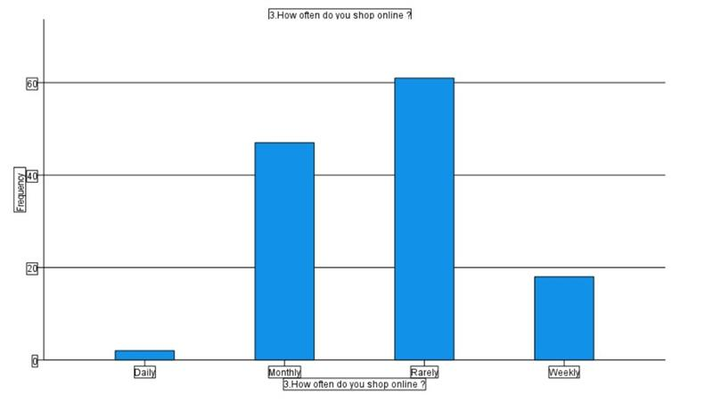

Fig 01: user frequency vs online shop usage

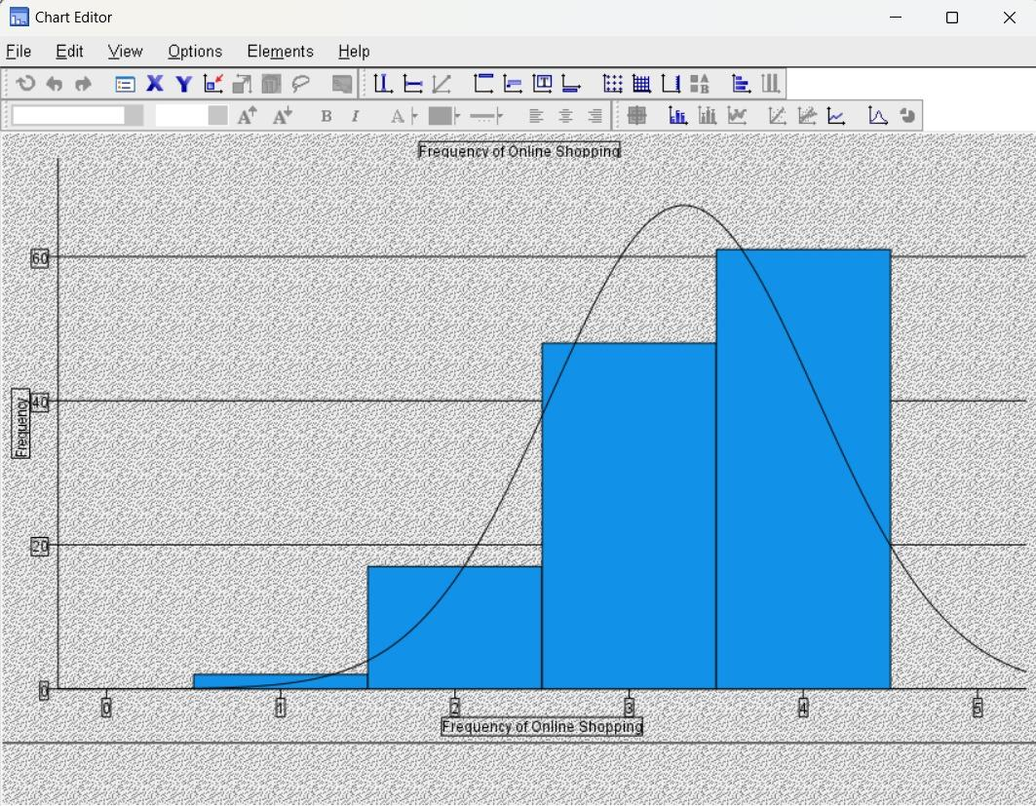

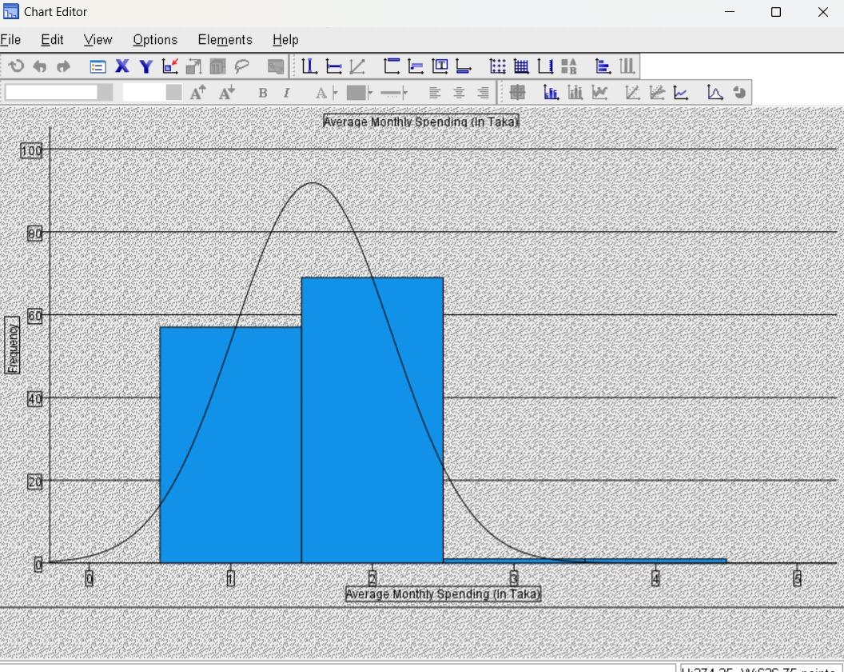
Fig 02: online shopping users

Fig 03: Average monthly expense

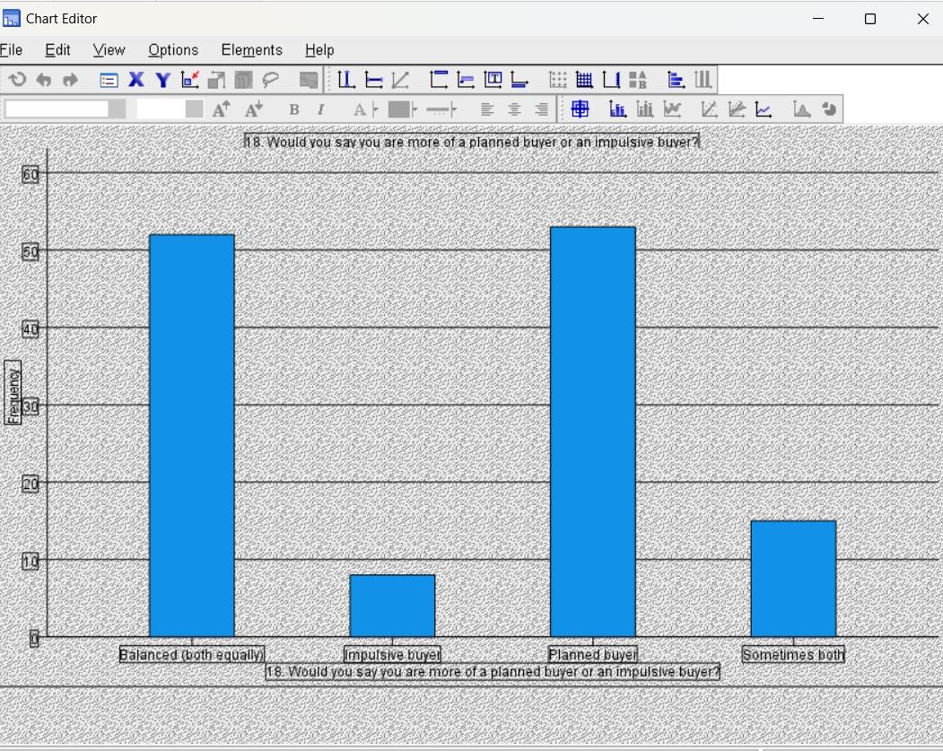
Fig 04: Buyer category
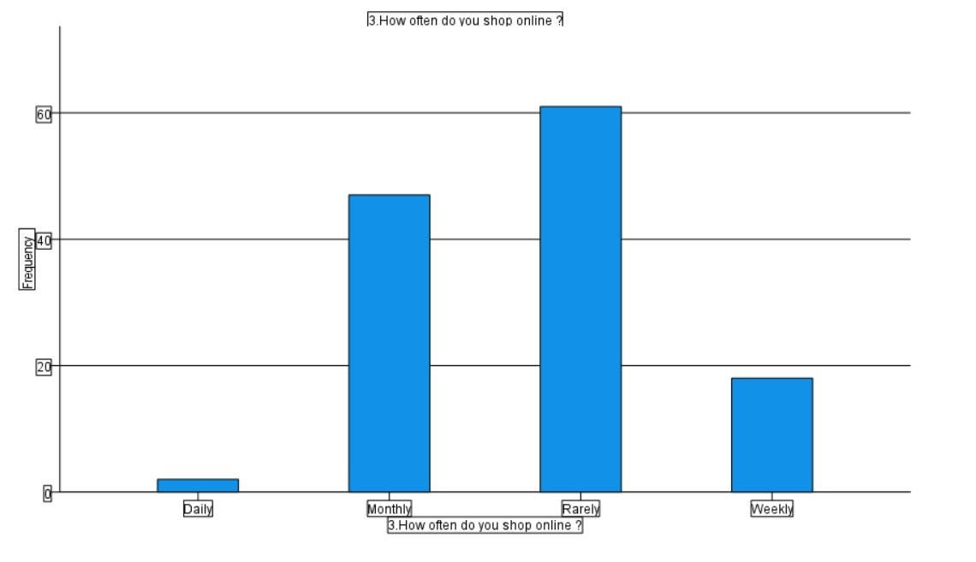

Fig 05: usage frequency

Pie Chart:
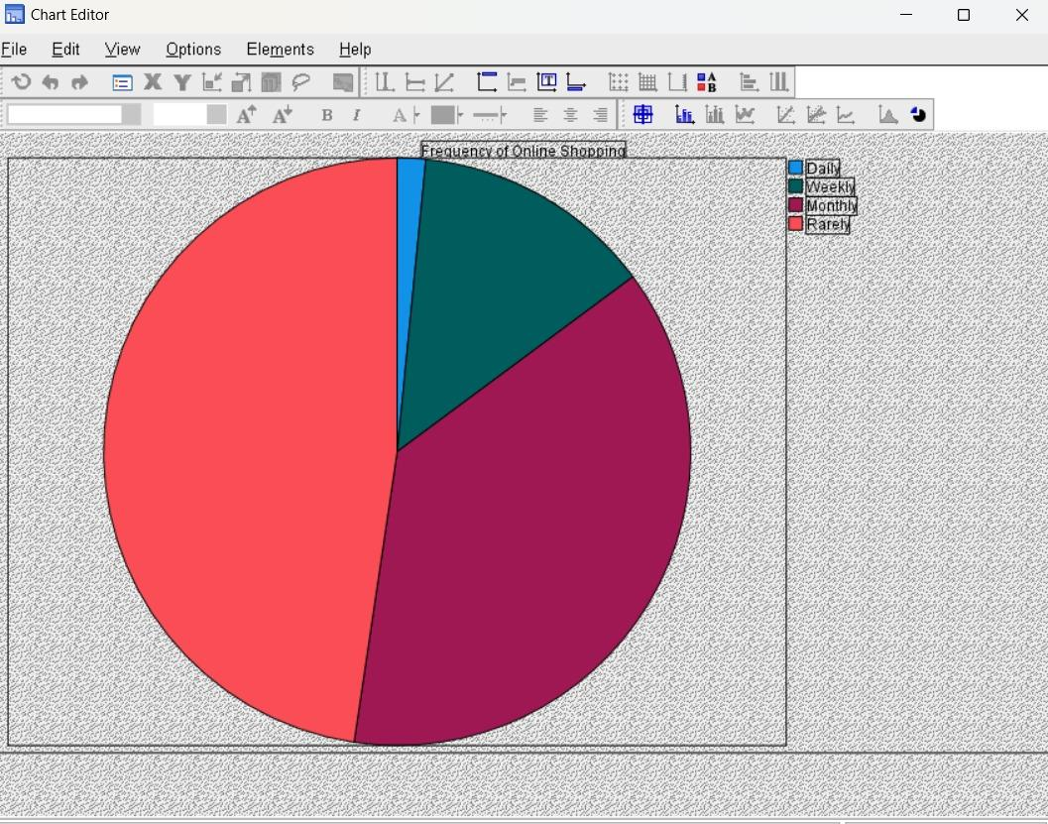

Fig 01: Usage frequency
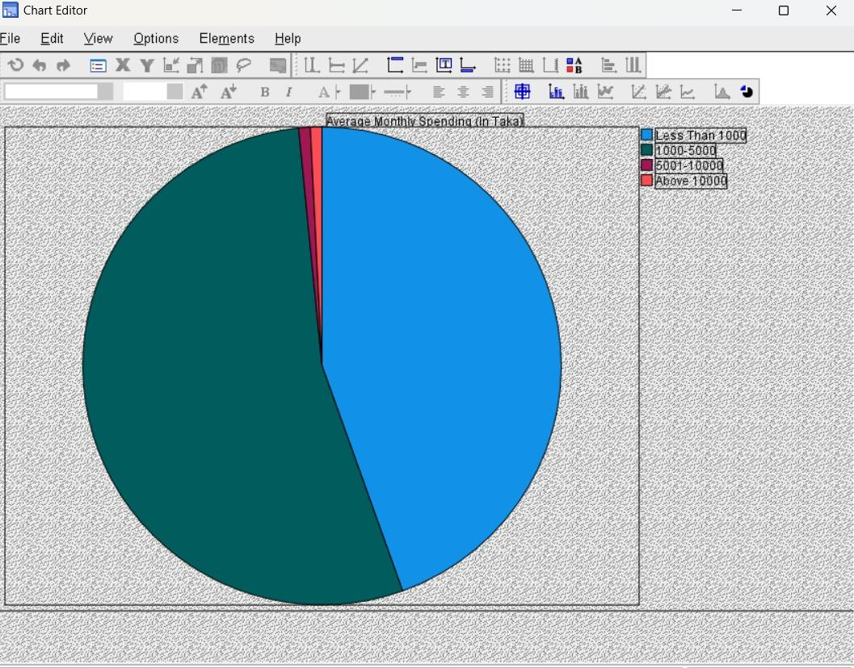

Fig 02: Monthly spending chart

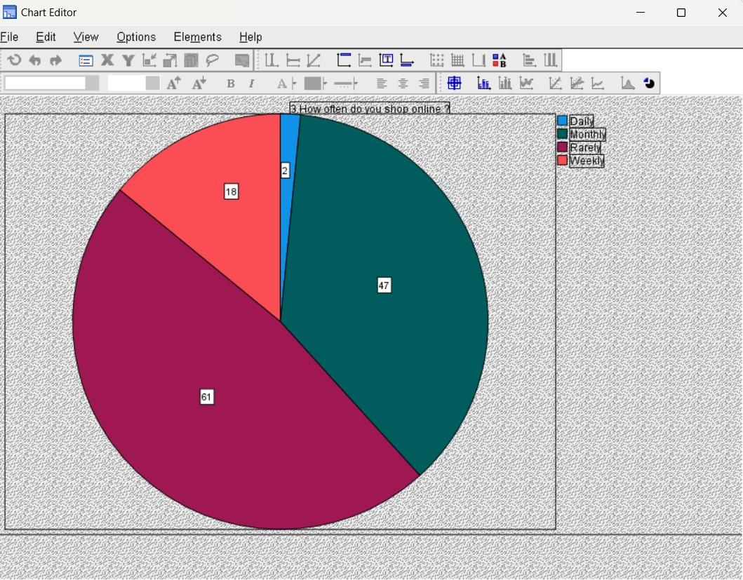
Fig 03: Usage pattern
Statical Data:

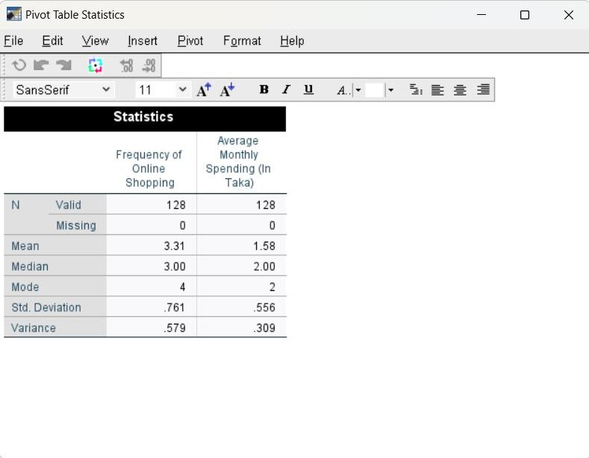

Fig 01: Mean, Variance, Median calculations

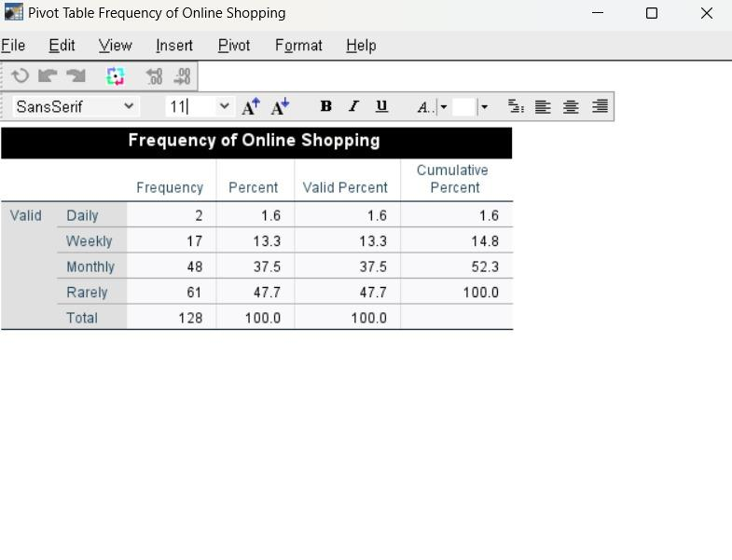

Fig 02: Online shopping frequency table

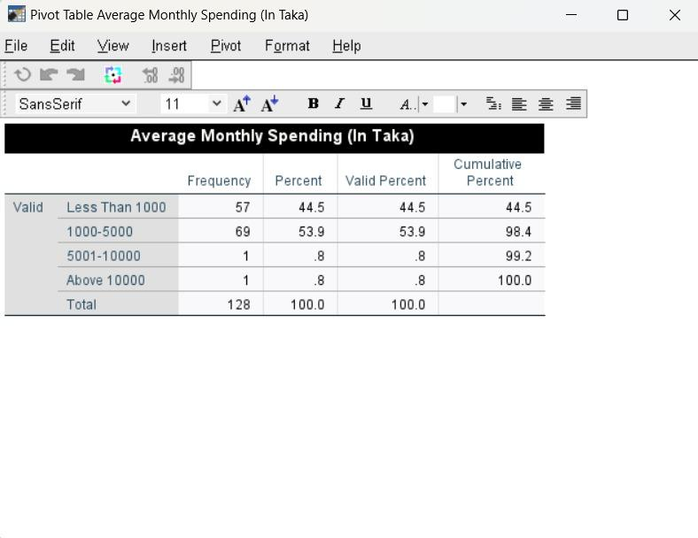

Fig 03: Average monthly expense table

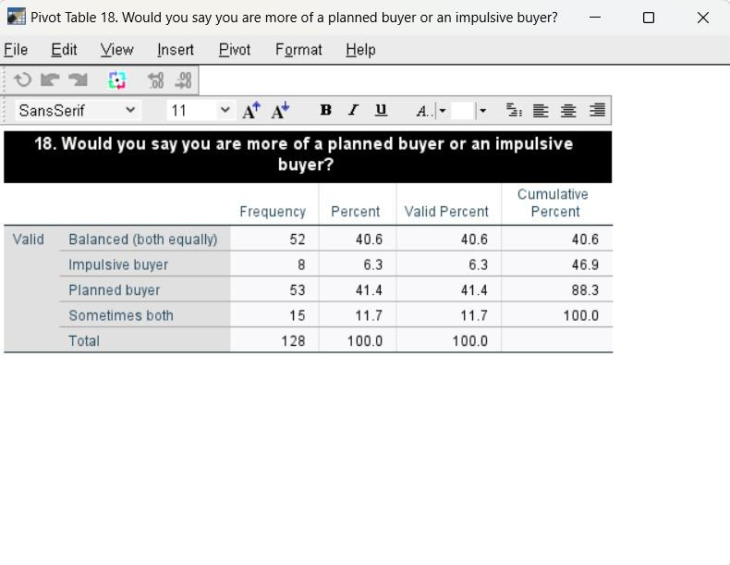

Fig 04: Buyers category table

Discussion:
The analysis of online shopping behavior revealed clear differences between impulse and planned buying. Most variables in the dataset were qualitative such as gender, occupation, and buyer type so only one quantitative variable (e.g., spending or frequency) was analyzed using mean, mode, and variance. These measures helped understand central trends and variability in purchasing behavior.
Visual tools like bar and pie charts effectively highlighted patterns in shopping habits. The data showed that many respondents engage in impulse buying, often influenced by advertisements, discounts, and emotions. In contrast, planned buying was more common among certain demographic groups, suggesting that factors like age and income impact purchasing decisions.
Conclusion:
This study highlights that impulse buying plays a major role in online shopping, driven largely by marketing triggers and emotional factors. Due to the limited number of numerical variables, statistical calculations were performed only for one variable, with most data analyzed qualitatively. Despite this limitation, the results show a clear difference between planned and impulsive buyers, suggesting that consumer spending behavior online is highly situational and influenced by external stimuli. Future studies should include more measurable variables for deeper statistical analysis.

